By Name You Are Called

The Spiritual Works of Mercy

September | Counsel the Doubtful | Do I point others in a good direction?
October | Instruct the Ignorant | Do I give others more time?
November – December | Admonish the Sinner | Do I stop the problem before it happens?
January | Comfort the Sorrowful | Do I listen when others feel hurt?
February | Forgive offenses willingly | Do I give others a second chance?
March | Bear wrongs patiently | Do I show patience toward others?
April –May | Pray for the Living and the Dead | Do I pray each day on my own?
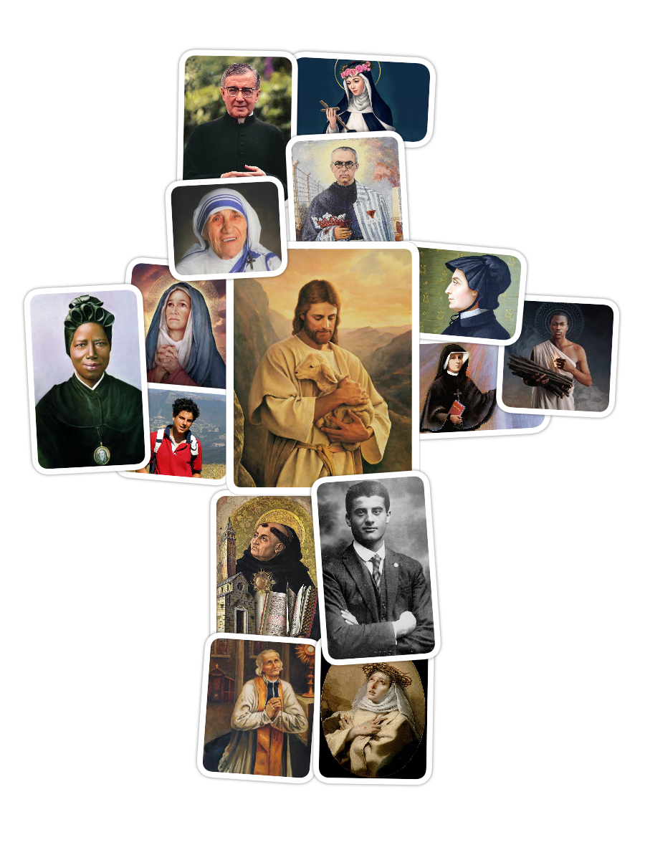
By Name You Are Called

The Spiritual Works of Mercy

September | Counsel the Doubtful | Do I point others in a good direction?
October | Instruct the Ignorant | Do I give others more time?
November – December | Admonish the Sinner | Do I stop the problem before it happens?
January | Comfort the Sorrowful | Do I listen when others feel hurt?
February | Forgive offenses willingly | Do I give others a second chance?
March | Bear wrongs patiently | Do I show patience toward others?
April –May | Pray for the Living and the Dead | Do I pray each day on my own?

Counsel the Doubtful

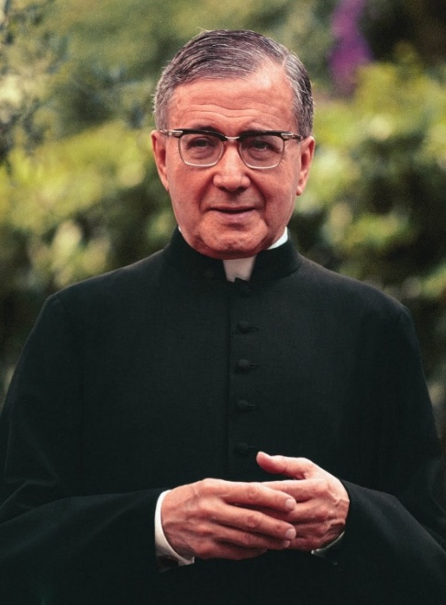
St. Josemaría Escrivá

“Don’t say, ‘I can’t be a saint.’ That’s not true! What’s more, there is no one who isn’t called to sanctity.”

St. Maria Faustina Kowalska
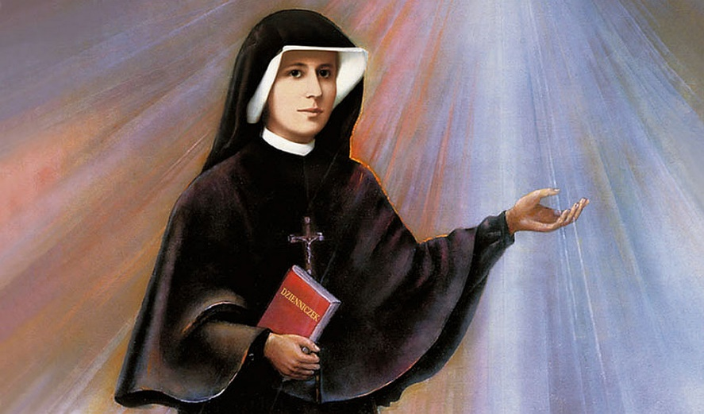

“Although the temptations are strong, a whole wave of doubts beat against my soul, and discouragement stands by, ready to enter into the act. The Lord, however, strengthens my will, against which all the attempts of the enemy are shattered as if against a rock.”

By Name You Are Called

The Spiritual Works of Mercy

September | Counsel the Doubtful | Do I point others in a good direction?
October | Instruct the Ignorant | Do I give others more time?
November – December | Admonish the Sinner | Do I stop the problem before it happens?
January | Comfort the Sorrowful | Do I listen when others feel hurt?
February | Forgive offenses willingly | Do I give others a second chance?
March | Bear wrongs patiently | Do I show patience toward others?
April –May | Pray for the Living and the Dead | Do I pray each day on my own?

Instruct the Ignorant
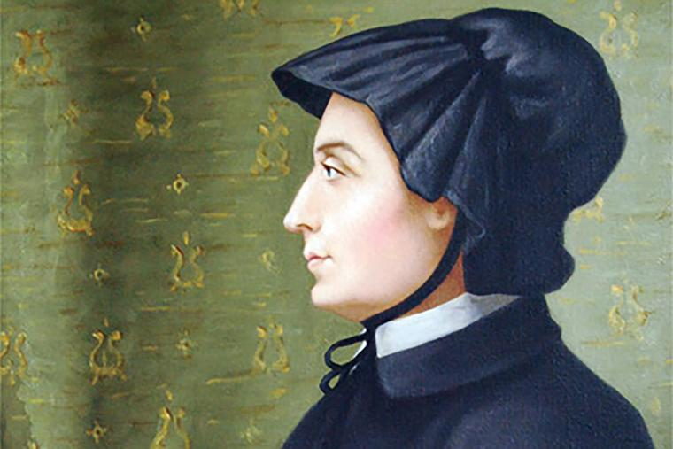
St. Elizabeth Ann Seton

“The first end I propose in our daily work is to do the will of God; secondly, to do it in the manner he wills it; and thirdly to do it because it is his will.”

St. Thomas Aquinas
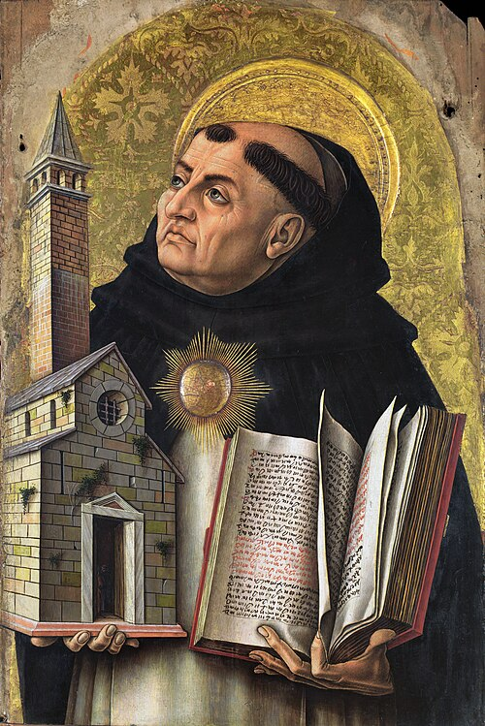

“To convert a soul is more excellent than to create the heavens.”

By Name You Are Called

The Spiritual Works of Mercy

September | Counsel the Doubtful | Do I point others in a good direction?
October | Instruct the Ignorant | Do I give others more time?
November – December | Admonish the Sinner | Do I stop the problem before it happens?
January | Comfort the Sorrowful | Do I listen when others feel hurt?
February | Forgive offenses willingly | Do I give others a second chance?
March | Bear wrongs patiently | Do I show patience toward others?
April –May | Pray for the Living and the Dead | Do I pray each day on my own?

Admonish the Sinner
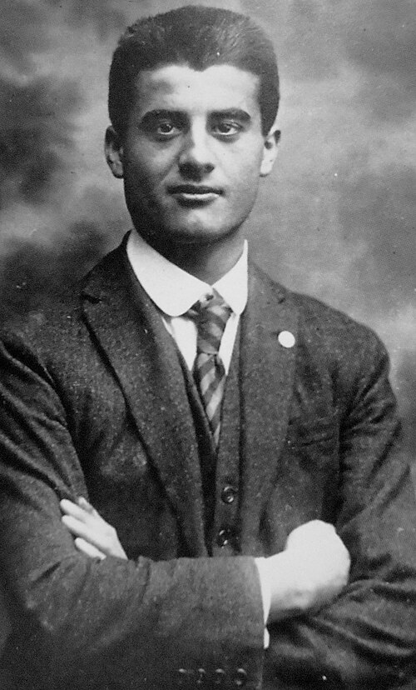

St. Pier Giorgio Frassati
“Foolish is he who follows the pleasures of this world, because these are always fleeting and bring much pain. The only true pleasure is that which comes to us through faith.”

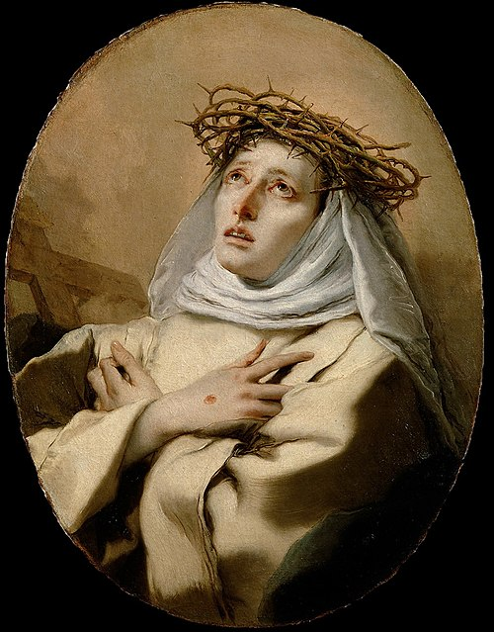

St. Catherine of Siena
“Do not be afraid. Be not afraid of anything. The will of God is our salvation; to follow it is our greatest pleasure.”
By Name You Are Called

The Spiritual Works of Mercy

September | Counsel the Doubtful | Do I point others in a good direction?
October | Instruct the Ignorant | Do I give others more time?
November – December | Admonish the Sinner | Do I stop the problem before it happens?
January | Comfort the Sorrowful | Do I listen when others feel hurt?
February | Forgive offenses willingly | Do I give others a second chance?
March | Bear wrongs patiently | Do I show patience toward others?
April –May | Pray for the Living and the Dead | Do I pray each day on my own?

Comfort the Sorrowful
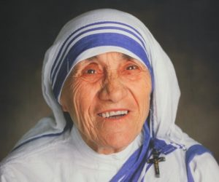
St. Mother Teresa

“Love begins at home, and it is not how much we do... but how much love we put in that action.”

St. Maximilian Kolbe
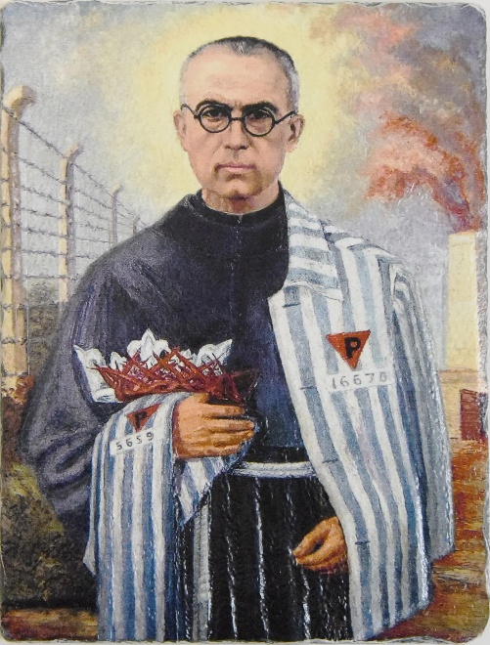

“No one in the world can change truth. What we can do and should do is to seek truth and to serve it when we have found it.”
By Name You Are Called

The Spiritual Works of Mercy

September | Counsel the Doubtful | Do I point others in a good direction?
October | Instruct the Ignorant | Do I give others more time?
November – December | Admonish the Sinner | Do I stop the problem before it happens?
January | Comfort the Sorrowful | Do I listen when others feel hurt?
February | Forgive offenses willingly | Do I give others a second chance?
March | Bear wrongs patiently | Do I show patience toward others?
April –May | Pray for the Living and the Dead | Do I pray each day on my own?

Forgive Offenses Willingly
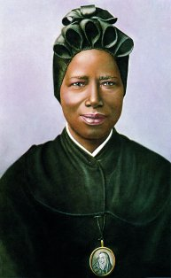

St. Josephine Bakhita
“Be good, love the Lord, pray for those who do not know Him. What a great grace it is to know God!”

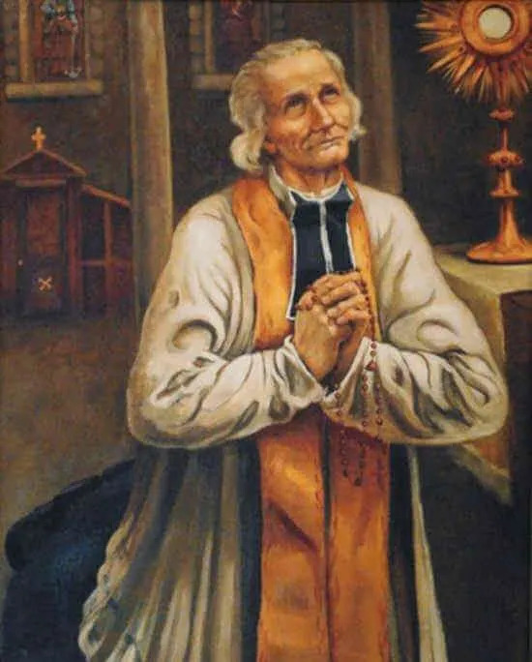

St. John Vianney
“Our errors are grains of sand beside the great mountain of God’s mercy.”
By Name You Are Called

The Spiritual Works of Mercy

September | Counsel the Doubtful | Do I point others in a good direction?
October | Instruct the Ignorant | Do I give others more time?
November – December | Admonish the Sinner | Do I stop the problem before it happens?
January | Comfort the Sorrowful | Do I listen when others feel hurt?
February | Forgive offenses willingly | Do I give others a second chance?
March | Bear wrongs patiently | Do I show patience toward others?
April –May | Pray for the Living and the Dead | Do I pray each day on my own?

Bear Wrongs Patiently
St. Rose of Lima
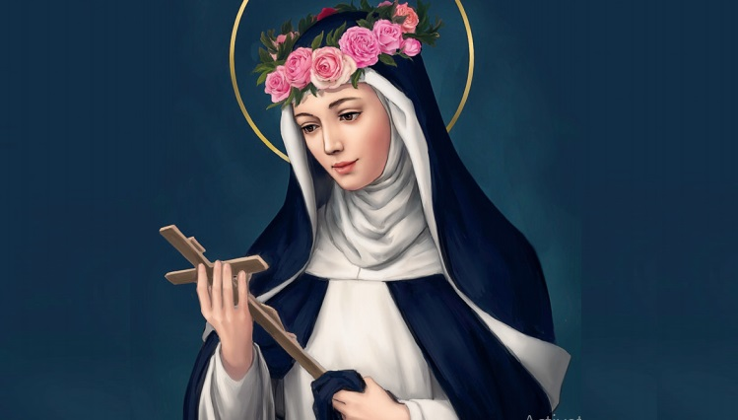

"The cross is the only ladder to heaven."

St. Charles Lwanga


“Do not be ashamed to confess the cross, for angels glory in it.”

By Name You Are Called

The Spiritual Works of Mercy

September | Counsel the Doubtful | Do I point others in a good direction?
October | Instruct the Ignorant | Do I give others more time?
November – December | Admonish the Sinner | Do I stop the problem before it happens?
January | Comfort the Sorrowful | Do I listen when others feel hurt?
February | Forgive offenses willingly | Do I give others a second chance?
March | Bear wrongs patiently | Do I show patience toward others?
April –May | Pray for the Living and the Dead | Do I pray each day on my own?

Pray for the Living and the Dead
St. Carlo Acutis
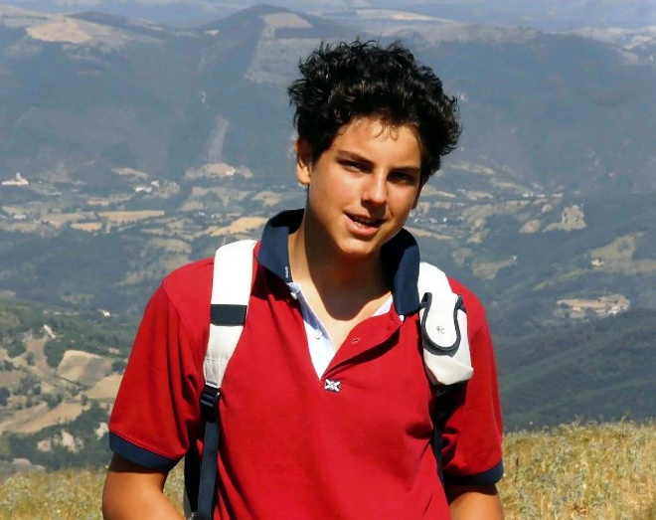

“Our goal must be infinite, not the finite. The infinite is our homeland. Heaven has been waiting for us forever.”

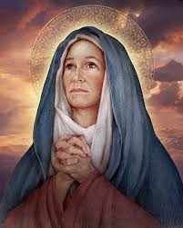
St. Monica

“I could not, indeed, have believed that he would have converted if it were not for the tears that I shed for him daily." (A paraphrase of her sentiments regarding her son, St. Augustine’s, conversion.)

Saint Details
Counsel the Doubtful:
- St. Josemaría Escrivá
  - As the founder of Opus Dei, St. Josemaría Escrivá dedicated his life to helping ordinary people find God in their everyday work and lives. Through his preaching, spiritual direction, and various writings, he offered practical guidance on how to live a genuine Christian life. He understood the doubts many people face about integrating faith into their modern professions, daily routines, and family life, continually encouraging souls to pursue holiness right where they are.
    - Quote: “Don’t say, ‘I can’t be a saint.’ That’s not true! What’s more, there is no one who isn’t called to sanctity.”
- St. Maria Faustina Kowalska
  - St. Faustina is a fantastic model for those counseling the doubtful because she dealt with her own moments of spiritual uncertainty and doubt regarding her visions. By staying focused on the message of Divine Mercy, she overcame her doubts and found strength. Her journey has become a source of comfort and guidance for many, helping deepen the Church’s understanding of Divine Mercy.
    - Quote: “Although the temptations are strong, a whole wave of doubts beat against my soul, and discouragement stands by, ready to enter into the act. The Lord, however, strengthens my will, against which all the attempts of the enemy are shattered as if against a rock.”

Instruct the Ignorant:
- St. Elizabeth Ann Seton
  - St. Elizabeth Ann Seton truly embodied the spiritual work of instruct the ignorant. She founded the Sisters of Charity of St. Joseph and poured her life into sharing the Catholic faith and educating all, especially those in need. For her, education was vital for empowering people and leading them to a deeper understanding of their faith and place in the world.
    - Quote: “The first end I propose in our daily work is to do the will of God; secondly, to do it in the manner he wills it; and thirdly to do it because it is his will.”
- St. Thomas Aquinas
  - Known as the “Angelic Doctor,” St. Thomas Aquinas was one of the most influential theologians and philosophers in the history of the Catholic Church. He performed the spiritual work of instructing the ignorant through his monumental work, the Summa Theologica, which systematized Catholic doctrine and made complex theological truths accessible and understandable. He dedicated his life to teaching and illuminating the faith for countless generations.
    - Quote: “To convert a soul is more excellent than to create the heavens.”

Admonish the Sinner:
- St. Pier Giorgio Frassati
  - St. Pier Giorgio Frassati lived out this work of mercy through the joyful and compelling witness of his own life. He drew friends and peers toward holiness not with stern warnings, but by inviting them into a life of adventure, service, and deep prayer. His infectious enthusiasm for the faith encouraged those around him to turn from sin and toward Christ, admonishing them by offering a more attractive and fulfilling way of life.
    - Quote: “Foolish is he who follows the pleasures of this world, because these are always fleeting and bring much pain. The only true pleasure is that which comes to us through faith.”
- St. Catherine of Siena
  - St. Catherine of Siena practiced this work of mercy with courageous love. As a laywoman, she boldly admonished popes and powerful political figures, calling them to reform and repent for the good of the Church and their own souls. Her letters contain frank and forceful corrections, yet they are always rooted in a profound love for Christ and a sincere desire for the spiritual well-being of those she addressed.
    - Quote: “Do not be afraid. Be not afraid of anything. The will of God is our salvation; to follow it is our greatest pleasure.”

Comfort the Sorrowful:
- St. Mother Teresa
  - Saint Teresa of Calcutta, the founder of the Missionaries of Charity, exemplified this work of mercy through her profound love for the poor, sick, and dying. Her life was a testament to comforting those in sorrow, as she and her sisters cared for society’s most destitute and abandoned members. Her ministry taught us to break free from bitterness and experience God’s love by actively loving and forgiving.
    - Quote: “Love begins at home, and it is not how much we do... but how much love we put in that action.”
- St. Maximilian Kolbe
  - A Franciscan friar, St. Maximilian Kolbe performed this act of mercy in the extreme circumstances of a Nazi concentration camp. He offered to take the place of a man who was condemned to death by starvation. This heroic sacrifice was a profound act of comfort, bringing peace and hope to a man consumed by sorrow. In their final moments, his prayers and presence brought solace and comfort to the other prisoners condemned alongside him.
    - Quote: “No one in the world can change truth. What we can do and should do is to seek truth and to serve it when we have found it.”

Forgive Offenses Willingly:
- St. Josephine Bakhita
  - St. Josephine Bakhita endured unimaginable cruelty, violence, and injustice after being kidnapped and sold into slavery multiple times. Despite the profound suffering inflicted upon her, she demonstrated the power of radical forgiveness. She famously stated that if she met her kidnappers and tormentors again, she would kneel and kiss their hands, because without them she might not have become a Christian and a religious.
    - Quote: “Be good, love the Lord, pray for those who do not know Him. What a great grace it is to know God!”
- St. John Vianney
  - As the patron saint of parish priests, St. John Vianney exemplified this work of mercy through his patient ministry. He was renowned for spending long hours in the confessional, listening to confessions from people near and far. His patience and willingness to help even the most difficult people made him a powerful model, showing his belief that even the worst sinners could find God’s mercy.
    - Quote: “Our errors are grains of sand beside the great mountain of God’s mercy.”

Bear Wrongs Patiently:
- St. Rose of Lima
  - St. Rose of Lima, a beautiful and pious young woman, faced numerous trials throughout her life. She was misunderstood by her family, who wanted her to marry for social gain rather than pursue a life of prayer and sacrifice. She also endured the slander of others who accused her of faking her mystical experiences. Rather than fighting back or succumbing to bitterness, she bore these wrongs with extraordinary patience, uniting her sufferings to the passion of Christ. Her patience was a profound act of charity, demonstrating that true strength lies in enduring injustice with a heart full of love.
    - Quote: "The cross is the only ladder to heaven."
- St. Charles Lwanga
  - St. Charles Lwanga was a catechist and the chief of the royal pages in the court of King Mwanga II of Buganda. As the king grew increasingly hostile toward Christianity, St. Charles patiently instructed and protected the younger pages in the faith. When the persecution began, he and his companions bore severe beatings, torture, and execution with a serene and heroic patience. They found their strength in prayer and love for Christ, enduring the ultimate wrong with grace and forgiveness.
    - Quote: “Do not be ashamed to confess the cross, for angels glory in it.”

Pray for the Living and the Dead:
- St. Carlo Acutis
  - A young man with a deep love for the Eucharist, St. Carlo Acutis lived this mercy with extraordinary fervor. He had a profound awareness of the spiritual needs of others and the reality of Purgatory. He frequently offered his prayers, daily Mass, and the Rosary for his friends, family, and the souls in Purgatory. His life’s mission was to bring people closer to Christ, both through his daily interactions with the living and his fervent intercession for the dead.
    - Quote: “Our goal must be infinite, not the finite. The infinite is our homeland. Heaven has been waiting for us forever.”
- St. Monica
  - St. Monica is renowned for her persistent and tearful prayers for the conversion of her son, Augustine, who lived a dissolute life for many years. Her unwavering prayer eventually led to his profound conversion, and Augustine would later become one of the greatest saints and Doctors of the Church. Highlighting her belief in praying for the dead, she specifically requested to be remembered at the altar of the Lord after her death.
    - Quote: “I could not, indeed, have believed that he would have converted if it were not for the tears that I shed for him daily." (A paraphrase of her sentiments regarding Augustine’s conversion.)

Saint image files can be found here:
https://photos.app.goo.gl/yMWYGhZawph2KfhM7

