Journeying with John Neumann

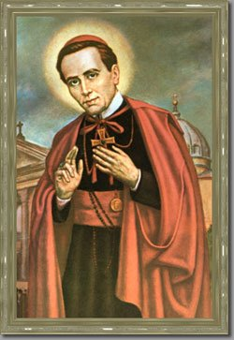

Tomorrow (January5) is the feast of St. John Neumann, the fourth bishop of Philadelphia and the first American male saint. John was born in Bohemia (now the Czech Republic) and came to the United States in 1836 (becoming a naturalized citizen in 1848). He was originally ordained for the Diocese of New York, where he served the German-speaking immigrants near Buffalo. A few years later he felt the call to community life and joined the Congregation of the Holy Redeemer (Redemptorists). Well-liked by his brothers, he was eventually appointed Provincial Superior. In 1852, Fr. John Neumann was named the bishop of Philadelphia, one of the largest Catholic dioceses in the country.
Wherever he was, whatever his role, John Neumann chose to care for the poor, the lonely, the abandoned, the disenfranchised. He went out to the people and thought nothing of traveling great distances to out-of-the-way towns, villages, and parishes to bring the sacraments and the Gospel to the People of God. With his traveling and interacting with people from many lands and walks of life, I find it fitting that Bishop John Neumann passed away (at the age of 48) on the Eve of the Epiphany (1860). Throughout his life, St. John would wander like the Magi, finding Christ in obscure areas of the country where newly arrived families were trying to make their homes. Like the Wise Men, St. John offered everything he had in service to God’s humble people.

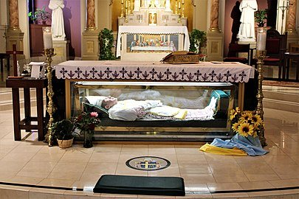

The National Shrine of St. John Neumann is located at St. Peter the Apostle Catholic Church in Philadelphia (5th & Girard Avenues). A visit to the Shrine is a great way to learn more about this man who lived a life of service. At the shrine, visitors can attend a mass, visit the museum or gift shop, make petitions, and pray to the saintly bishop whose remains are under the altar.
Similar to St. Francis de Sales, St. John Neumann was a bishop who called all people (clergy, religious, and laity) to offer their gifts, talents, and vocation to the One who was born to bring life and light to the world. St. John Neumann called the people of his day to offer service and shelter to the widow, the orphan, the outsider, and the immigrant.
As we approach Epiphany, may we bring the light we recognized on Christmas to all the world In imitation of St. John Neumann, may we also recognize that light in all of our sisters and brothers, especially the least of God’s people.
Happy Feast of St. John Neumann, Blessed Epiphany!

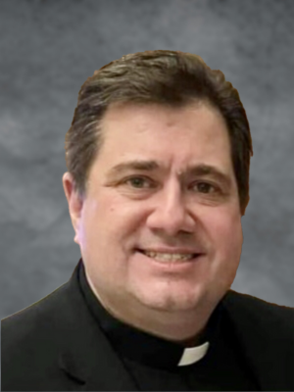

Fr. Jack Kolodziej, OSFS
Provincial
Wilmington-Philadelphia Province

