February 8, 2024

Dear Delaware School Principals and Leaders:

As Delaware’s Lieutenant Governor, I invite you to apply for the third annual National Lieutenant Governors Association (NLGA) Lt. Governors’ STEM Scholarship Program, a program I was proud to establish while serving as chair of the NLGA. This is an excellent program that is very near and dear to my heart, and I am hopeful that several Delaware schools will compete for this scholarship.

NLGA will award up to $1,000 to 12 schools in 12 states and territories to support STEM-related programming, projects, equipment, curriculum, and other endeavors. The application period is open until March 15, 2024. Scholarship applications are welcome from pre-K – 12th grade state-accredited public or private schools, and tribal schools.

Applications for the Scholarships should be submitted by a teacher or project supervisor for STEM-related expenses by March 15, 2024. Funding will be awarded directly to your school in Spring 2024, with receipt of the funding to be acknowledged by the school within 90 days.

Identify and share this information with any teachers or project supervisors to support STEM-related projects in your school. To apply:

- Visit nlga.awardsplatform.com (no www) and register with an email address and password. A verification email will be sent to you. Click the link in that email to begin your submission. If you have already registered, login using your email address and password.
- After logging in, click START APPLICATION. Under “CATEGORY”, select “NLGA Lt. Governors’ STEM Scholarship Program” from the pull-down menu and review the information on the page. Give your application a name.
- Complete the fields within the application. You have the option to submit attachments in support of your application for funding.
- Click SUBMIT APPLICATION when complete.
- Contact kritters@nlga.us for assistance.

For more information, visit https://nlga.us/strategies/nlga-state-strategies-in-stem/ or contact NLGA at 859-283-1400.

Sincerely,
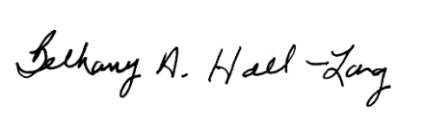
Bethany A. Hall-Long
Lieutenant Governor of Delaware

