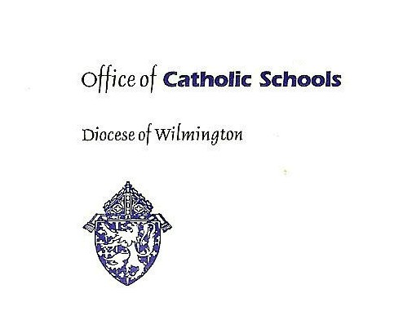

Professional Standards for Catholic School Educators

Standard 1: Ministry of Catholic Education

Catholic school educators are called to be ministers who model and proclaim the Word of God.

An effective instructor in a Catholic school in the Diocese of Wilmington is expected to adhere to the following indicators:

- Adheres to the teachings of the Catholic Church and the policies established by the Diocese of Wilmington
- Models and supports the school’s mission
- Participates in school liturgies, prayer services, service opportunities, and other religious activities at school
- Gives witness to Gospel values in communications and interactions with all members of the school community
- Integrates Catholic doctrine in all curricular areas
- Engages in on-going faith formation opportunities

Standard 2: Professional Knowledge

Catholic school educators are expected to demonstrate an understanding of and ongoing growth in curriculum, subject content, instructional strategies, and the developmental needs of students.

An effective instructor in a Catholic school in the Diocese of Wilmington is expected to adhere to the following indicators:

- Exhibits a comprehensive knowledge of the prescribed standards-based curriculum
- Shows mastery of and remains current in subject content
- Explores current educational research and instructional strategies
- Understands the cognitive and affective development of students
- Displays awareness of the diversity of students, families, and the community

Standard 3: The Learning Environment

Catholic school educators are expected to create and maintain a learning environment that evidences Catholic values.

An effective instructor in a Catholic school in the Diocese of Wilmington is expected to adhere to the following indicators:

- Maintains a welcoming, organized, current physical space which encourages active engagement in learning and reflects the Catholic Identity of the school
- Creates an atmosphere of respect and rapport that supports learning and values individual differences
- Establishes well-organized classroom procedures and routines
- Communicates, models, and expects high standards of responsible student behaviors
- Assumes responsibility for the care of the classroom and instructional materials

Standard 4: Planning and Preparation of Instruction

Catholic school educators are expected to plan instruction based on the understanding of student needs, current curriculum, subject matter, and teaching strategies.

An effective instructor in a Catholic school in the Diocese of Wilmington is expected to adhere to the following indicators:

- Designs lesson and/or unit plans that consider student developmental needs, backgrounds, and learning styles
- Develops clear instructional goals and student learning objectives (essential questions) that align with curriculum standards
- Integrates a variety of instructional strategies to include teacher-led instruction, independent work, student presentation, and student-driven activities
- Incorporates available resources, including technology, in lesson and/or unit planning
- Plans fair and equitable groupings for student collaboration and interaction
- Prepares high quality instruction and assessment with materials that support the development of higher-order thinking skills

Standard 5: Quality of Instruction

Catholic school educators are expected to motivate, engage, and challenge every student through the implementation of well-planned instruction that fosters critical thinking and creativity.

An effective instructor in a Catholic school in the Diocese of Wilmington is expected to adhere to the following indicators:

- Follows the prescribed curriculum with appropriate pacing
- Begins class with clearly stated student learning objectives (essential questions)
- Communicates clearly and accurately with students
- Engages and motivates students in active, purposeful learning that encourages the development of critical and creative thinking as well as problem solving skills
- Manages instructional time effectively
- Implements a variety of instructional strategies to address the diverse learning styles, cultural differences, and individual needs of all students
- Integrates available technology that correlates with learning goals
- Monitors student progress and provides timely feedback
- Demonstrates flexibility and responsiveness

Standard 6: Assessment of Learning

Catholic school educators are expected to utilize valid and diverse assessment methods designed to measure student understanding and progress.

An effective instructor in a Catholic school in the Diocese of Wilmington is expected to adhere to the following indicators:

- Aligns assessments to curriculum standards
- Provides a variety of suitable assessment strategies, both formative and summative, that reflect the stated goals and student learning objectives (essential questions)
- Utilizes appropriate rubrics for grading student generated work
- Modifies assessment techniques for learners with special needs
- Records and communicates assessment results in a timely and organized manner
- Analyzes assessments and standardized testing to determine areas of strength and weakness in curriculum areas to adjust instruction as needed
- Recognizes that the cumulative grade includes student growth and progress

Standard 7: Professionalism

Catholic school educators are expected to model Catholic values and demonstrate professional responsibility at all times.

An effective instructor in a Catholic school in the Diocese of Wilmington is expected to adhere to the following indicators:

- Upholds high standards of integrity and confidentiality
- Engages in on-going spiritual formation and professional development that meets the requirements for catechetical and state certification/licensing
- Demonstrates growth by applying and implementing knowledge and skills attained by professional development
- Communicates effectively and in a timely manner with students and parents/guardians using established school protocols
- Maintains accurate records of parent conferences and concerns
- Complies with professional obligations including personal appearance and demeanor as designated by the school
- Participates in school and/or diocesan activities, projects, or committees
- Accepts additional duties, willingly, as needed

